LAMBTON COLLEGE



**A Report on**

[**Lab 1,2,3 on** [**AWS Academy Data Analytics**](https://moodle.queenscollege.ca/moodle/mod/lesson/view.php?id=436567)**]**

121 Brunel Rd, Mississauga

ON L4Z 3E9

A Group assignment with screenshots of Lab 1, 2, and 3

on Aws academy

Big Data Analytics DSMM

**Under the supervision**

**of**

**Professor Teresa Zhu**

**Submitted BY:**

Aadarsha Chapagain (C0825975)

Roshan Acharya (C0831342)

Anjana Kuriakose (C0829580)

Onyinye Mbanefo (C0831578)

**Submitted To:**

Lambton College

Professor Teresa Zhu

**Submission Date:**

27th  November 2022

# Lab1: Store data in Amazon S3

## Task 1: Create an IAM user account

### Task 1.1: Review users and group permissions in the IAM console

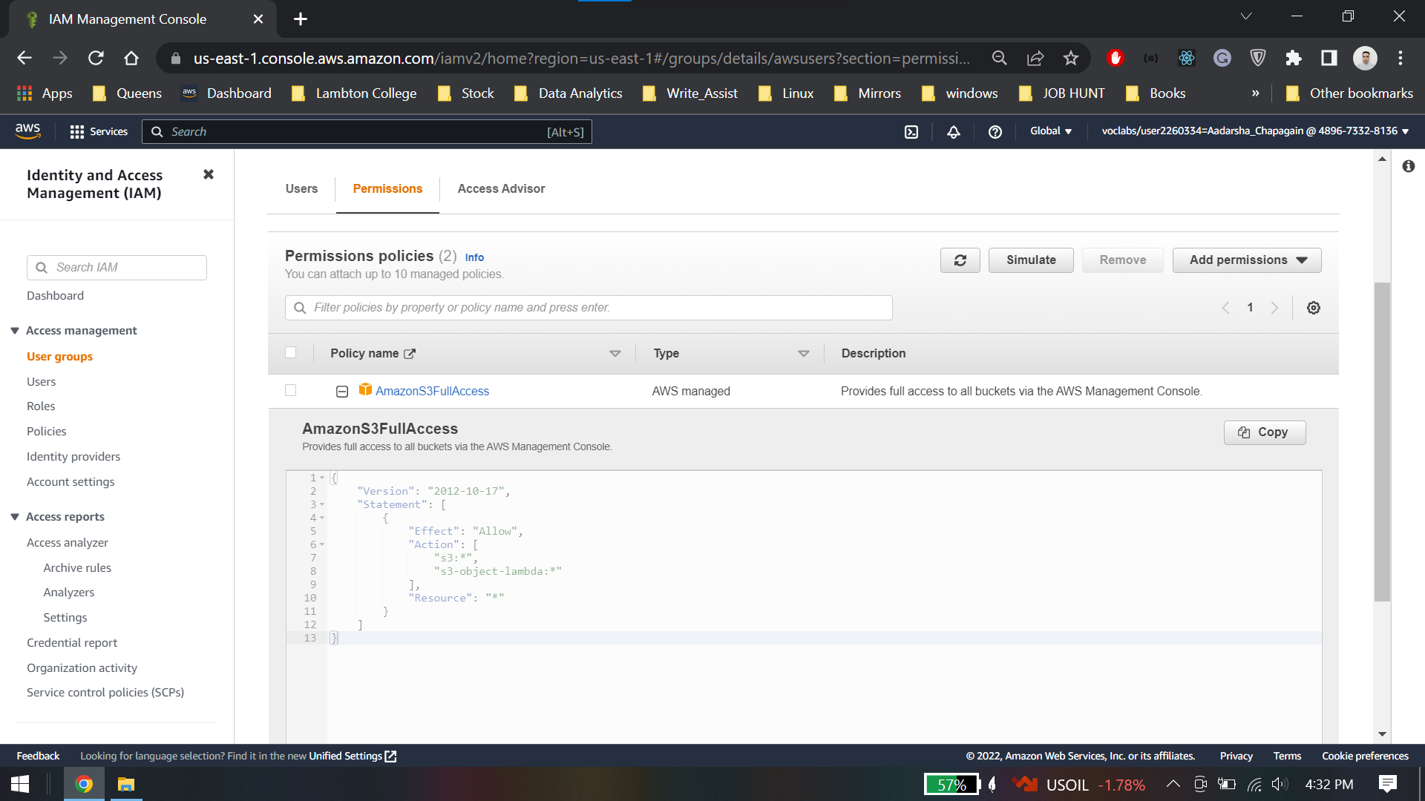

Task 1.2: Add awsuser to the awsusers group

AccountId: 489673328136

## Task 2: Load data into Amazon S3

### Task 2.1: Create an S3 bucket

Bucket name: dabucket11

### Task 2.2: Upload an object

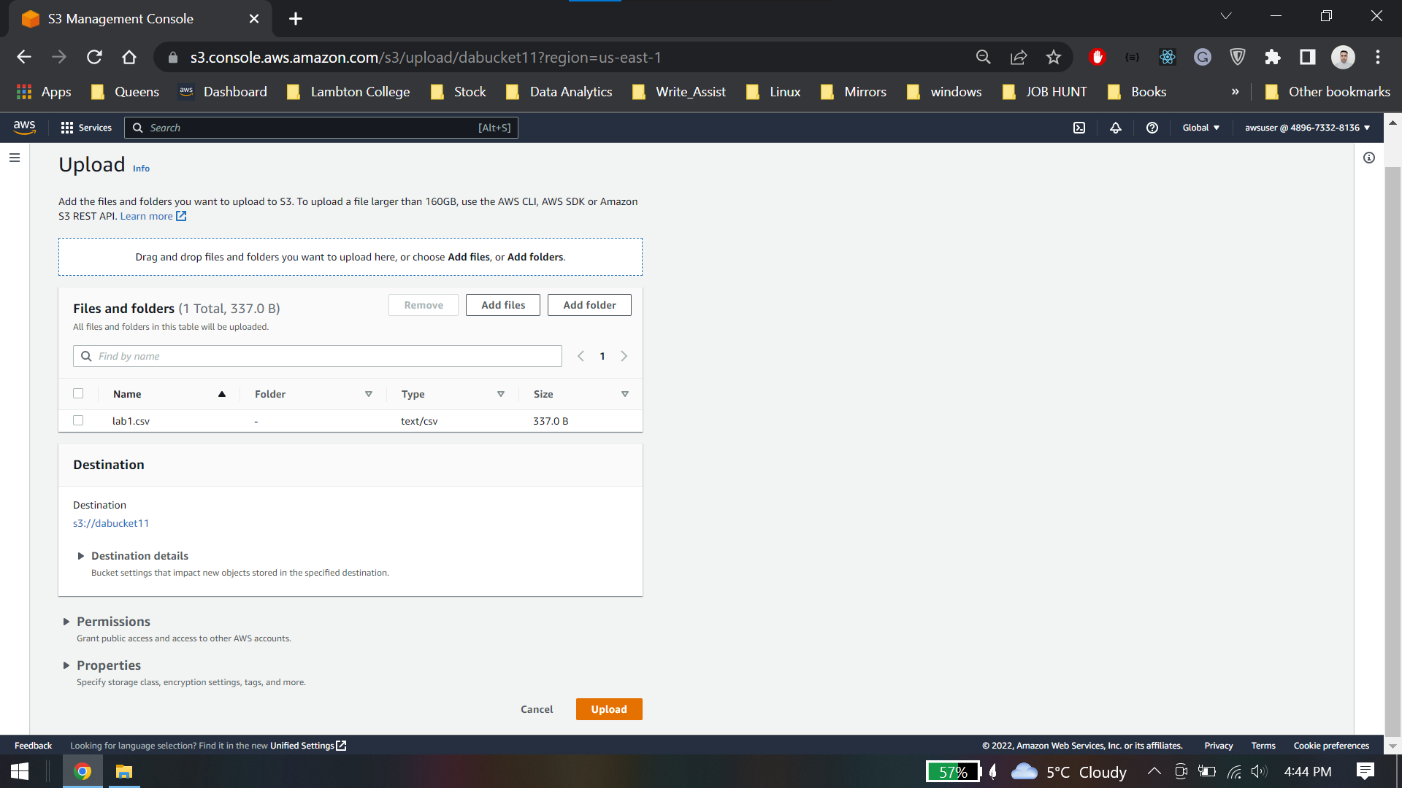

### Task 2.3: Query the object you uploaded

### Task 2.4: Change the encryption properties and storage type

### Task 2.5: Upload a compressed file

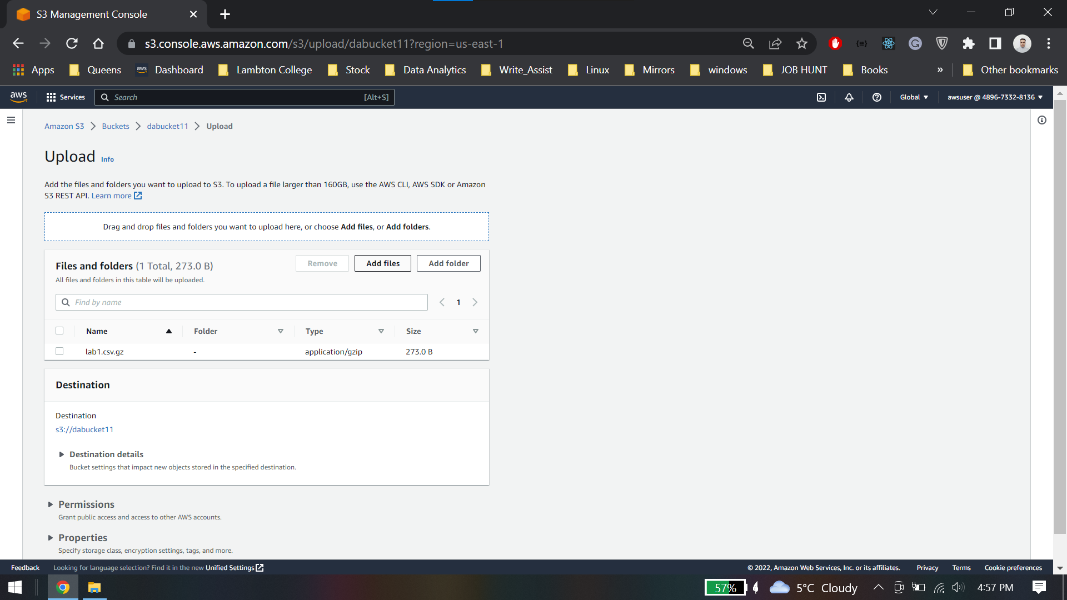

Compressed file can be queried in the same way as a non-compressed file.

## Lab 1 Conclusion.

* Access Amazon S3 in the AWS Management Console
* Secure an S3 bucket with IAM
* Create a bucket with Amazon S3
* Load data into an S3 bucket
* Query an S3 bucket

# Lab 2: Query Data in Amazon Athena

## Task 1 : Query Data in Amazon Athena

Bucket ARN: arn:aws:s3:::c69170a1364268l3191571t1w086574625150-s3bucket-q3gdz12cykyj

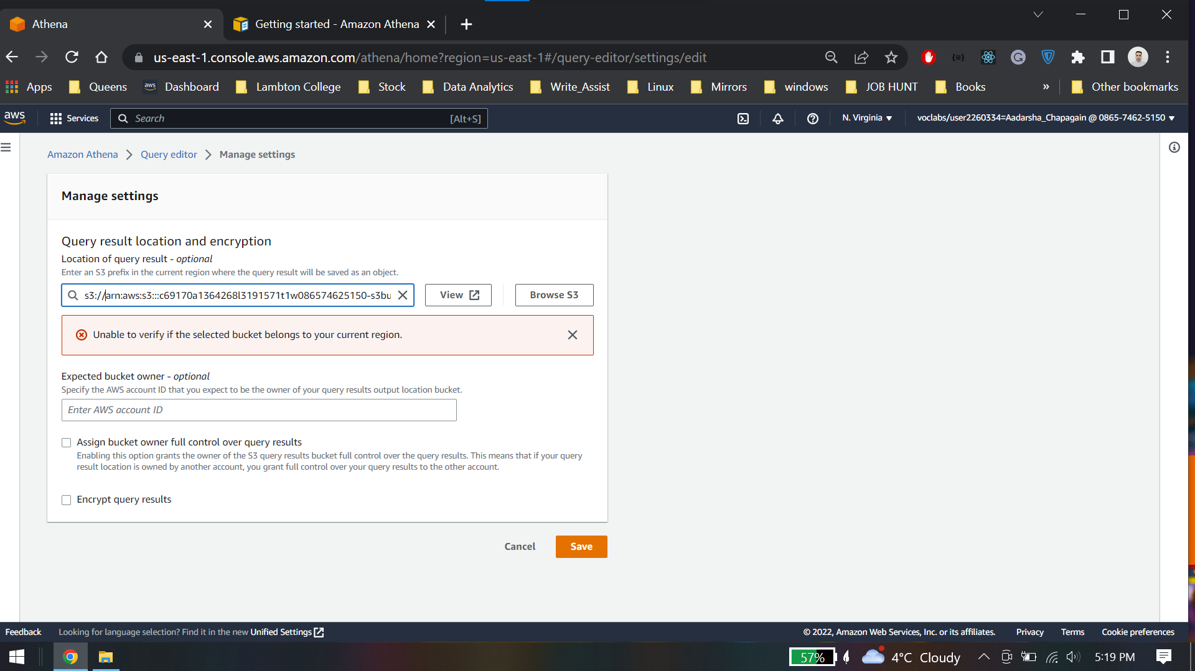

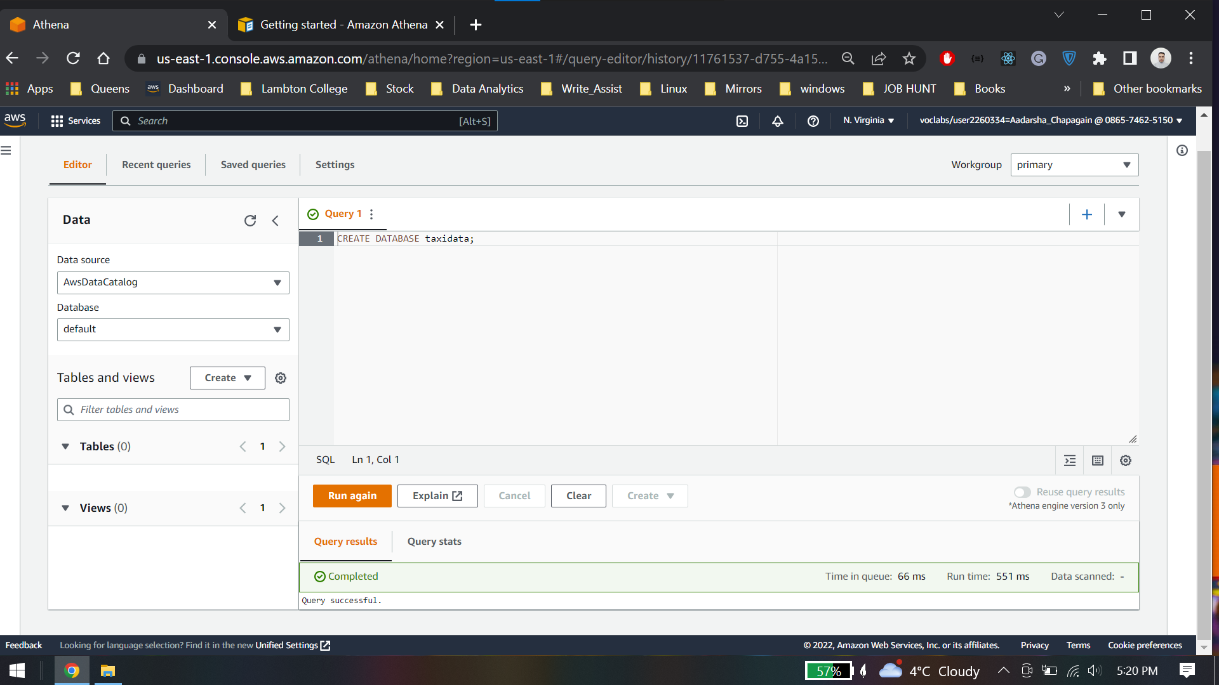

## Task 2: Optimize the database

### Task 2.1: Create a table for the January 2017 data

### Task 2.2: Run a query using the data that is not divided into buckets

### Task 2.3: Run a query using the data that is divided into buckets for each month

Following results was found

* No buckets:
  + Total data scanned: 9.32 GB
* Buckets:
  + Total data scanned: 815 MB

Task 2.4: Query partitioned data

### Task 2.4.1: Partition the data

Yellow table:

Run time: 7.19 seconds & Data scanned: 9.32 GB

Credit card table:

Run time: 3.32 seconds & Data scanned: 71.8 MB

## Task 3: Create and query views

## Lab2 Conclusion

* Accessed Athena in the AWS Management Console
* Created tables and define data types
* Queried data in Amazon S3 from Athena
* Optimized queries with partitioning

# Lab 3: Query Data in Amazon S3 with Amazon Athena and AWS Glue

## Task 1: Create a crawler for the GHCN-D dataset

Create a Crawler

Choose Iam role

Create a database

Output Configuration

### Task 1.1: Run the crawler

### Task 1.2: Review the metadata created by AWS Glue

### Task 1.3: Edit the schema

## Task 2: Query the table using the AWS Glue Data Catalog

### Task 2.1: Create a table for data after 1950

Create a bucket in same region

Create a table specifying the bucket location

Preview table

### Task 2.2: Run a query from the selected data

Create a view

Preview the data

Average maximum temperature from 1950 to 2018

Results

## Lab 3 Conclusion

* Accessed AWS Glue in the AWS Management Console
* Created a crawler with AWS Glue
* Created tables and a schema with AWS Glue
* Queried data in Amazon Simple Storage Service (Amazon S3) from Amazon Athena with the AWS Glue data catalog